

**Website Project**

**Topic : The Fashion**

**Dynamic website report**

**Lecturer Name: Lypengleang Seang**

**Group Name :**

**Hout Sokreaksmey**

**Huot Sophearin**

**Heng Ratha**

**Week 1 :**

What is the project?

We create websites in order to manage selling and buying, keep in touch with products and are easy to process.

Why did we choose this topic?

We choose this project because we are focusing on web development as an alternative for people to get these information and knowledge on online shopping than from TV. We choose the opportunity that we can provide

The good template to business online. This platform can help heighten their knowledge and enhance their ability to know and understand about the world.

What is our goal of making this happen?

Our goal :

* This website can provide users with information on products that are hosted online without visiting a shop.
* For owner : can manage stock and manage products with process buying and selling.
* For customer payment : the owner can allow the customer to use the method of payment that the customer wants and the owner can keep the report.

How many people build this platform?

The first , We have three people on our team and we start with new experiences at web material.

We start with front-end HTML + CSS + JAVASCRIPT, Bootstrap, PHP framework and more step we started to see similar website which have almost the content and beautiful layout so we followed their style of the fashion web moreover, we also got support from W3school web and especially plenty of method and tool from our instructor.

For the back-end we focus on databases that store data and resources. We use Mysql and PHP Framework (Laravel).

* **Sophearin**

**Site Map front-end**

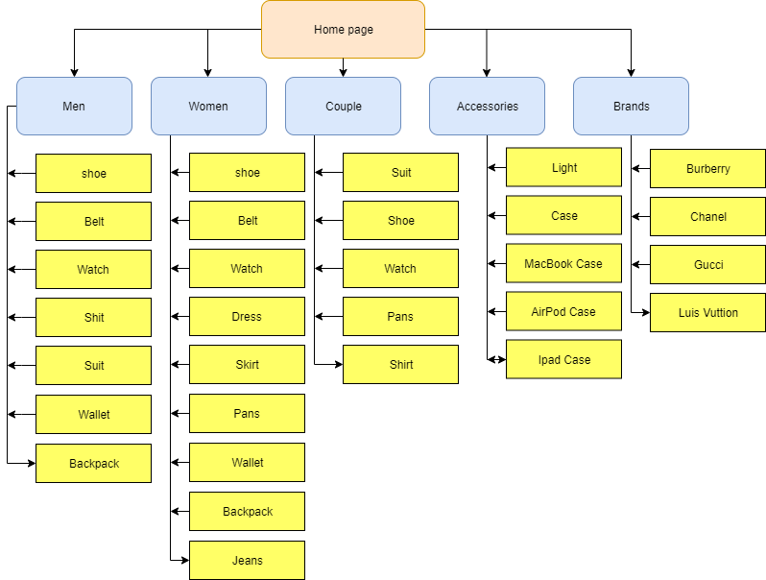

**Site Map Back-end**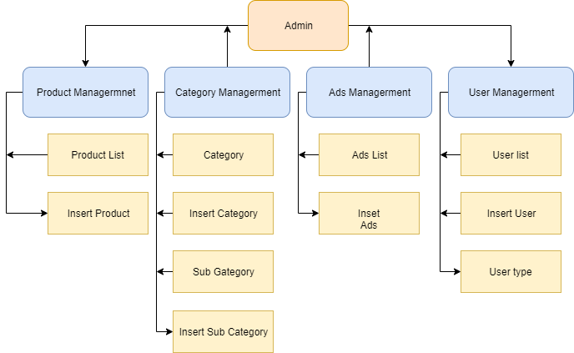

* **Sophearin:**  Arrange HTML overall structure + CSS style of home page + home page content + slide home page and menu (static)

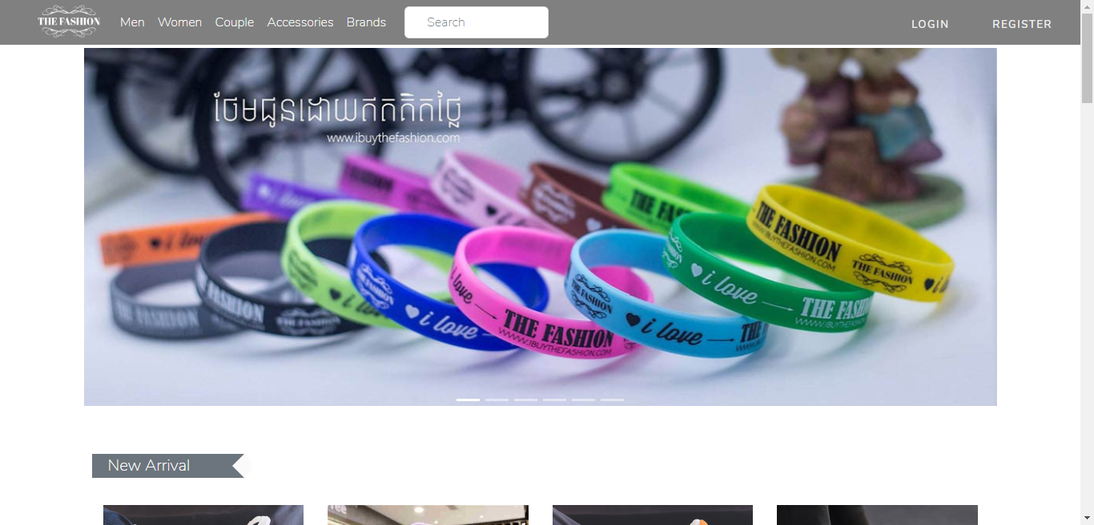

* **Ratha**: Arrange HTML + CSS style of category Men (Static)

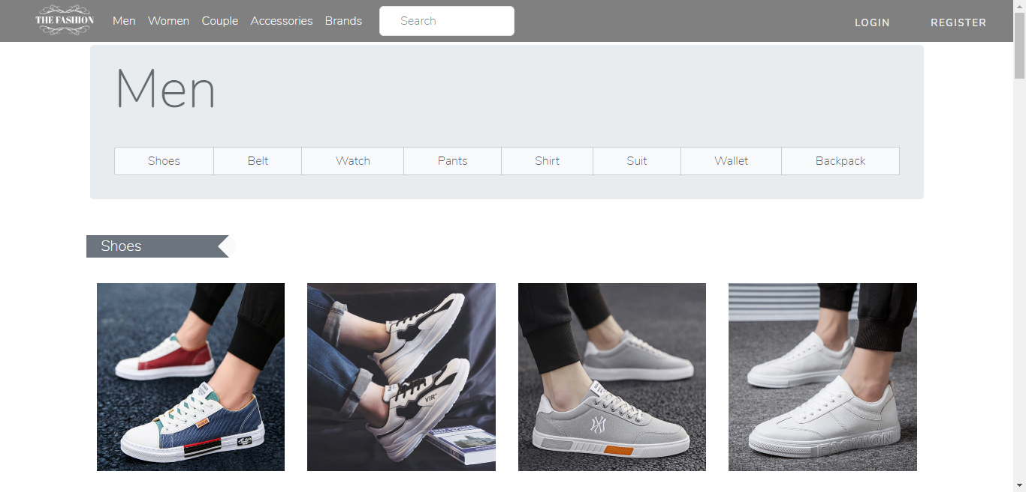

* **Reak Smey:** Design Form Login, Register and created CRUD in User Management and Ads Management
* Login

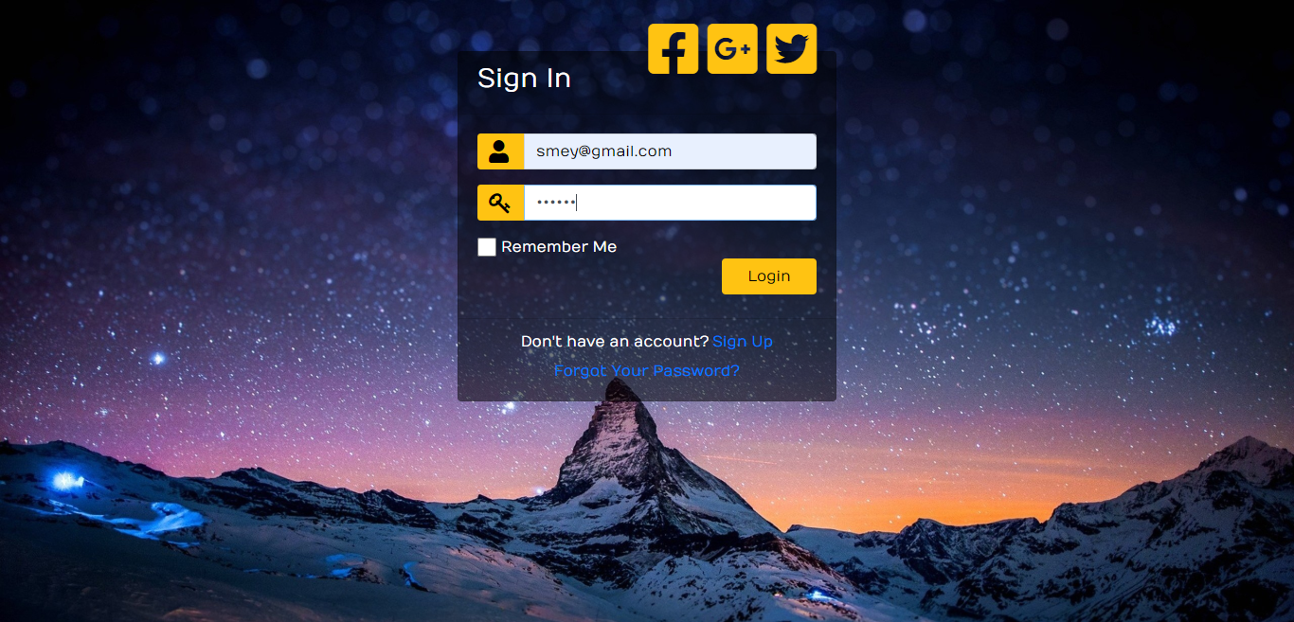

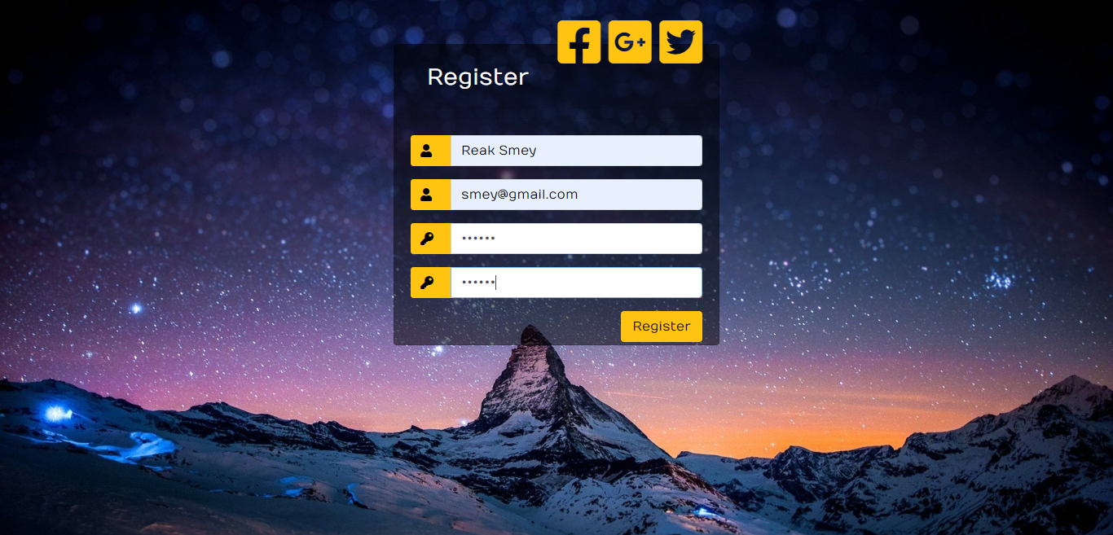

* User Management

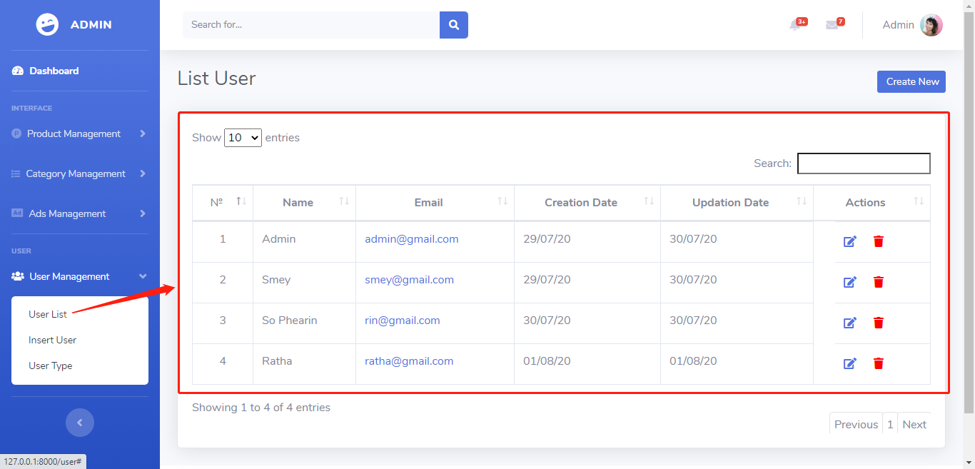

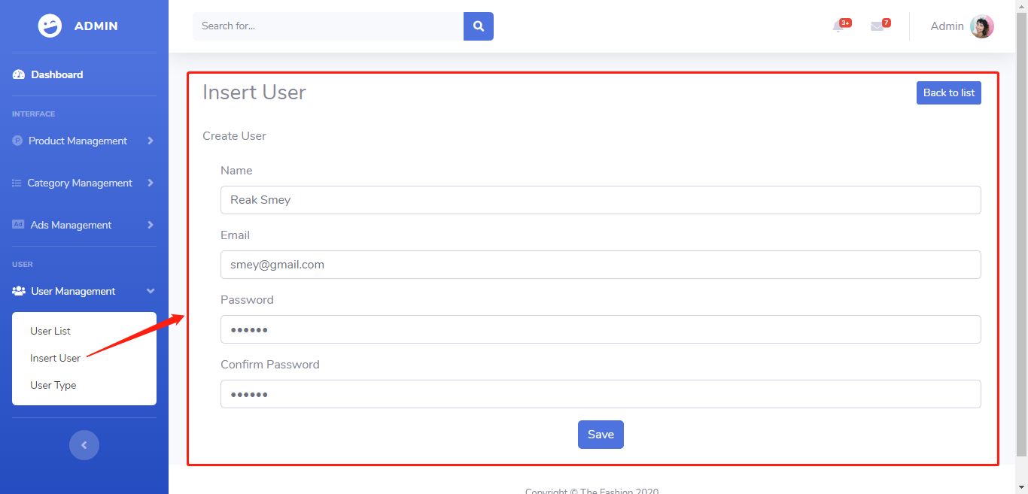

* Ads Management

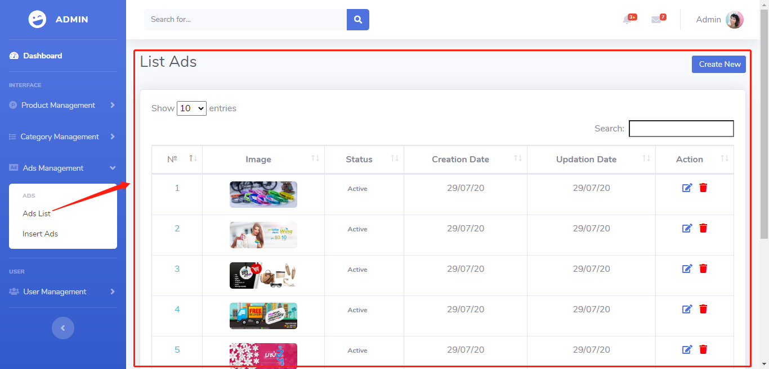

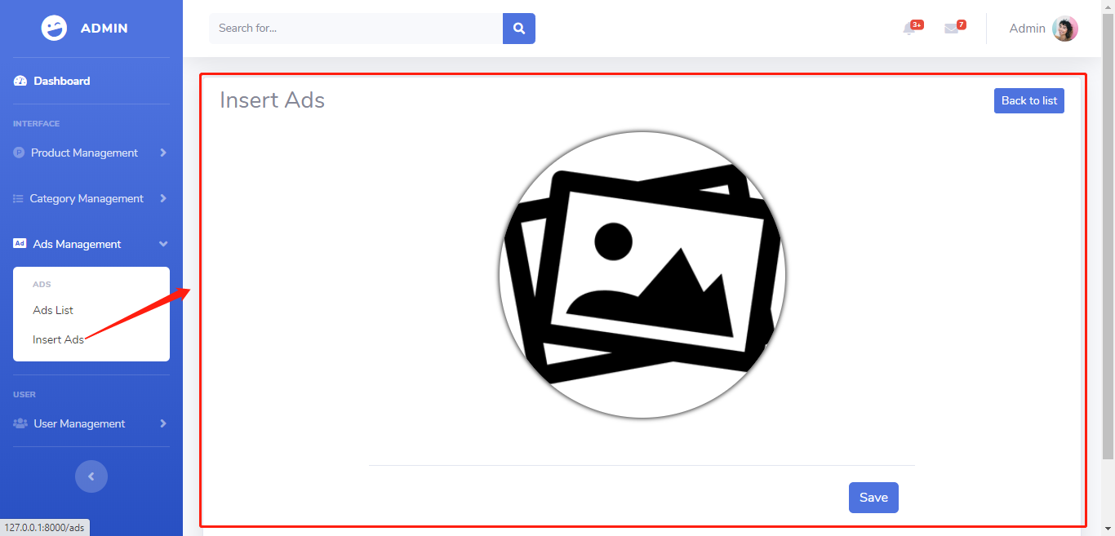

**Week 2 :**

* **Sophearin:** Working on Product detail

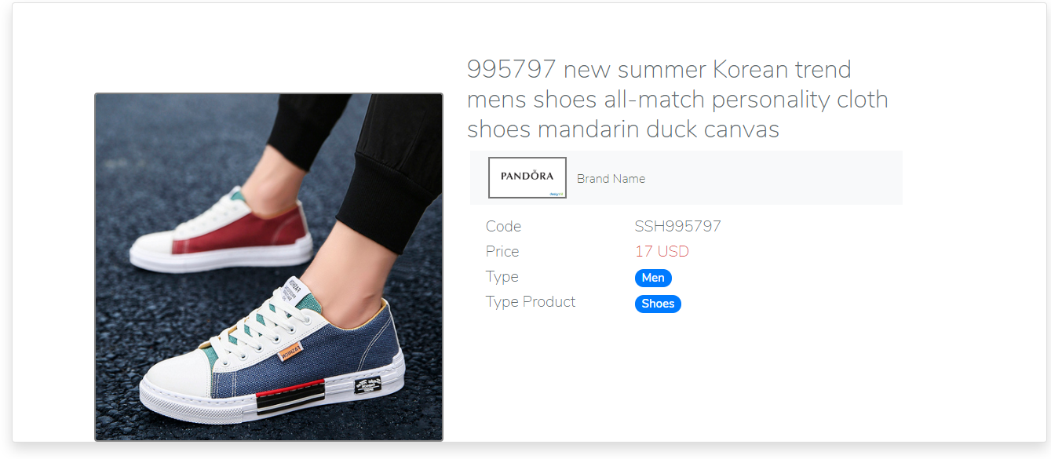

* **Ratha:** Working on footer and Privilege Parner

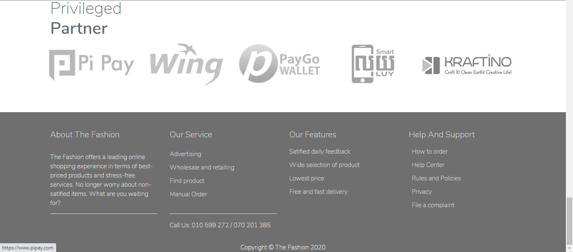

* **Reak Smey:** Created CRUD in Category management (category and sub category)
* Category

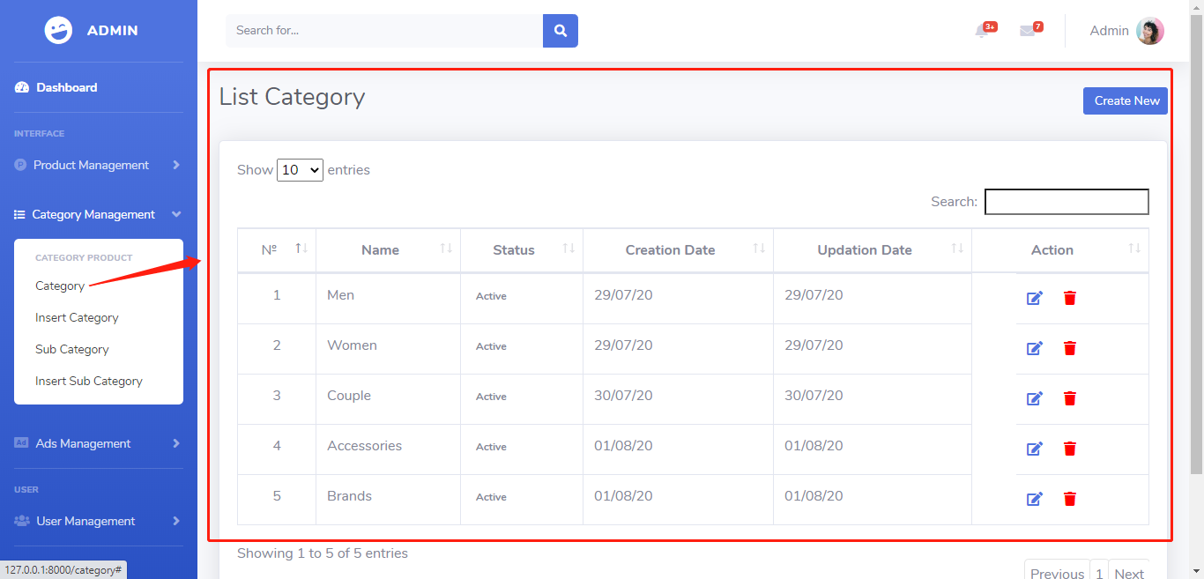

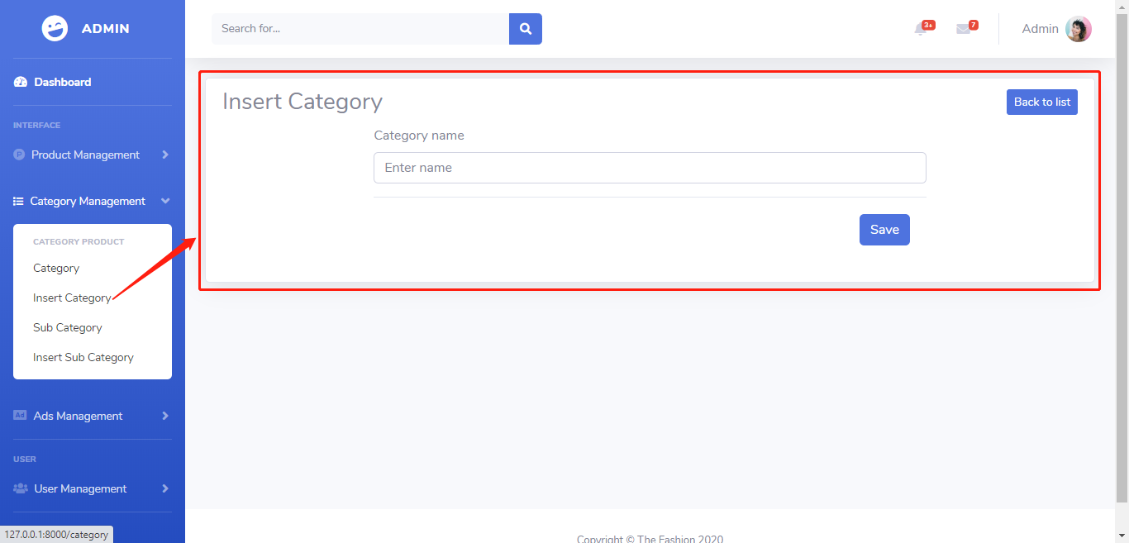

* Sub Category

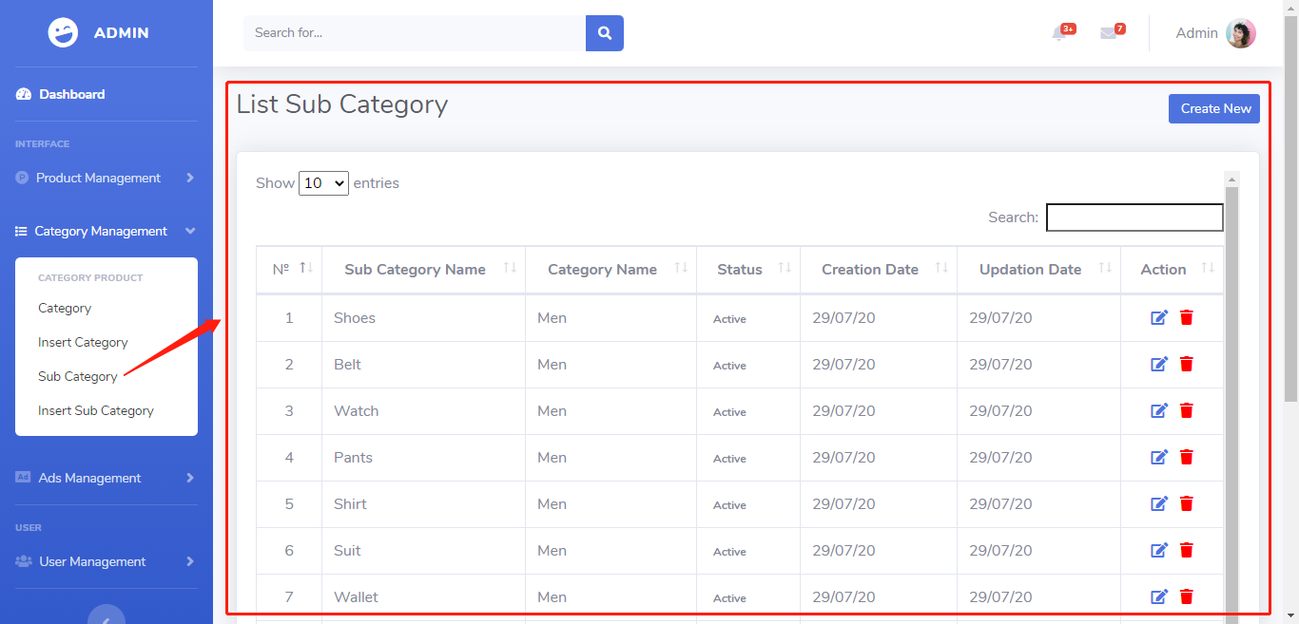

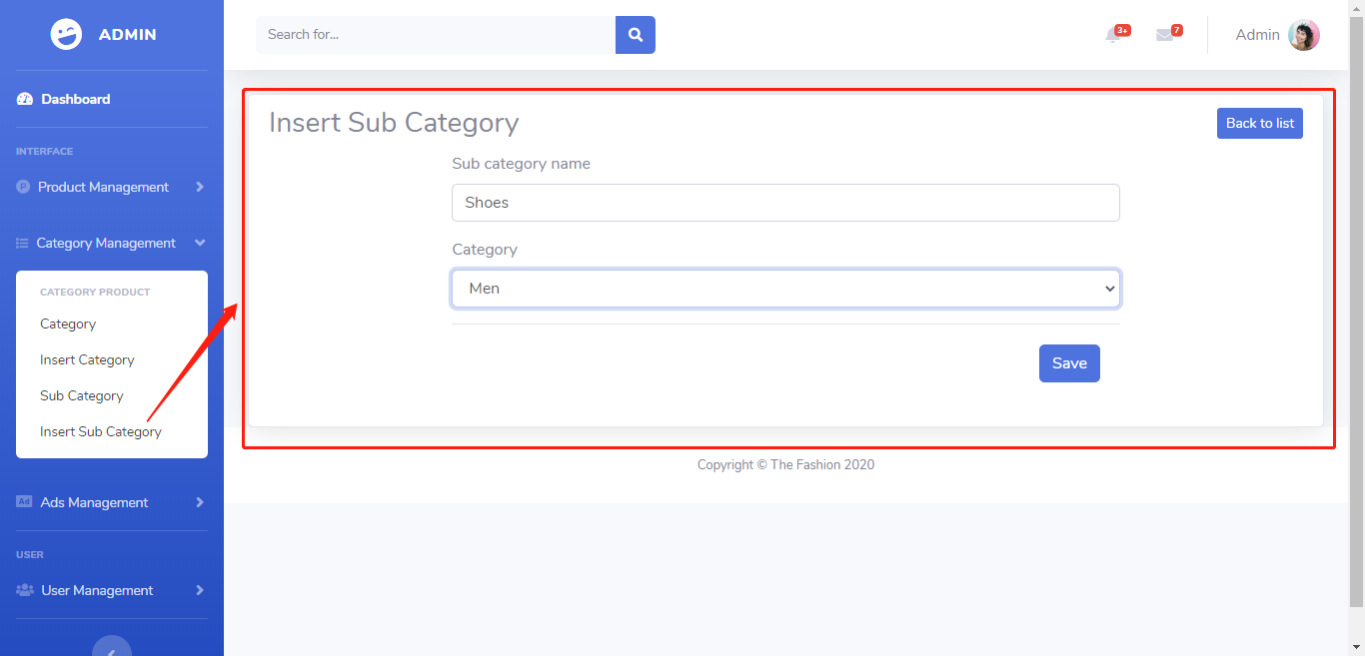

**Week 3 :**

* **Reak Smey:** Create CRUD in Product Management and pass data to view dynamic on frontend (slide category and sub category)
* Product

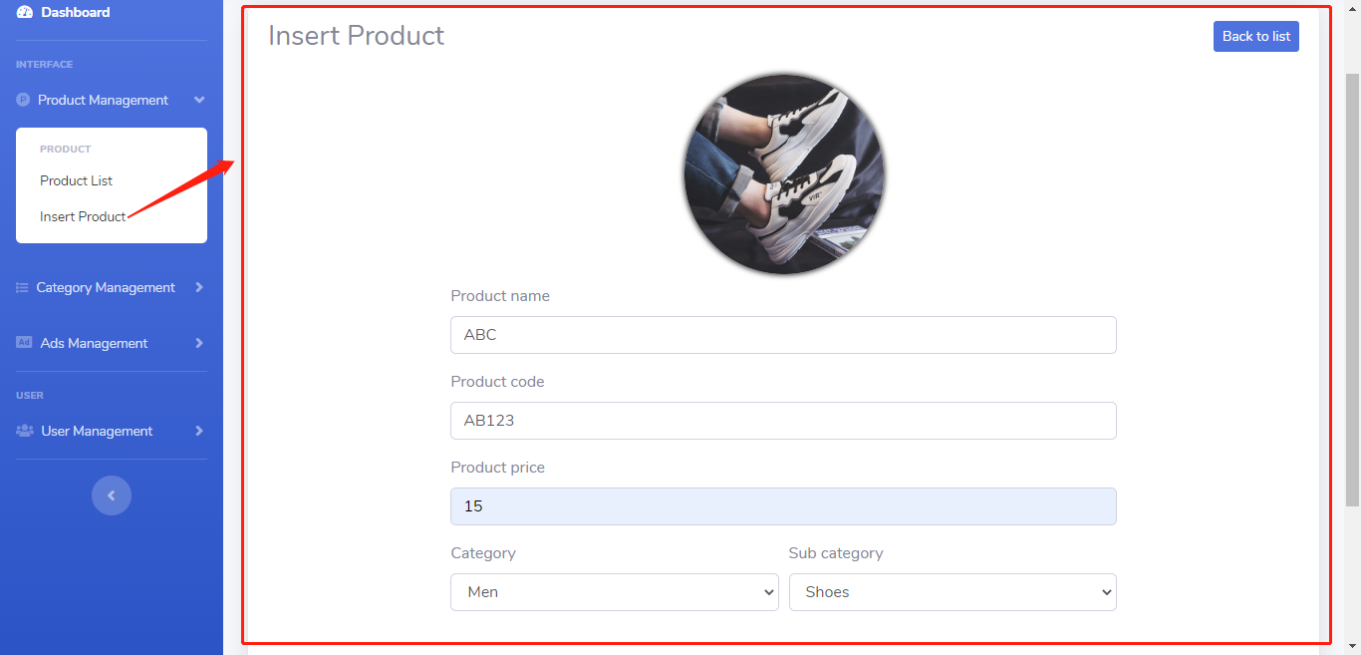

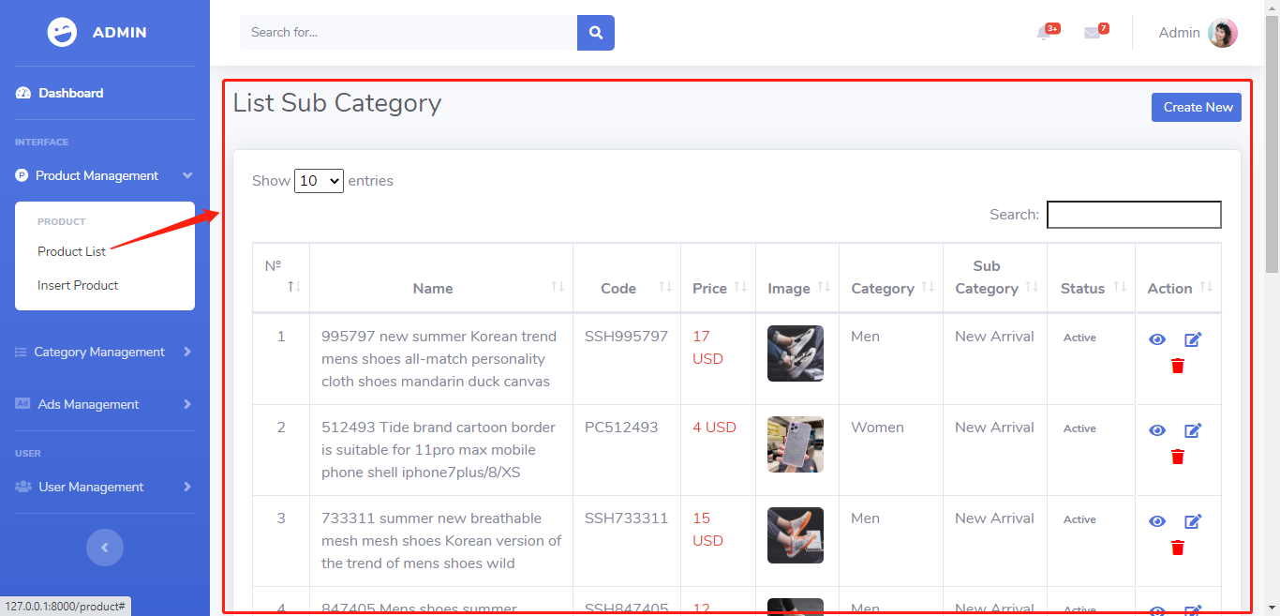

**Reference:** 

<https://thefashion.asia/>

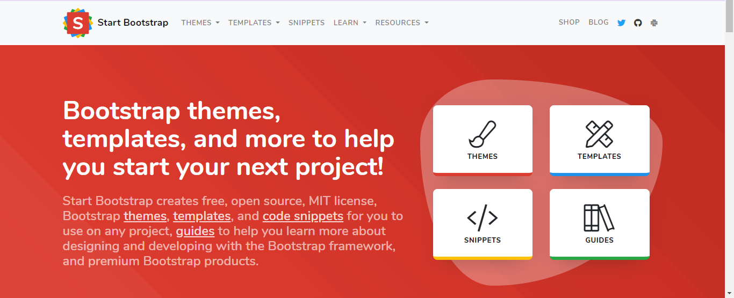

<https://startbootstrap.com/>



<https://www.w3schools.com/>



<https://getbootstrap.com/>